INFR 3120U – Web and Script Programming
Lemuel Lau – 100520773

Project Plan for Recipe Sharing Website: RepShare
RepShare is a website that allows users to share, view, and manage their recipes online. The website includes the ability to create, update, edit, and delete recipes. Recipes are displayed in organized cards and users can easily navigate through the site and perform CRUD operations.

The site currently has homepage with a simple layout with two buttons that redirect to the other pages of the site. Future updates would potentially include a background picture displaying potential recipes or meals.
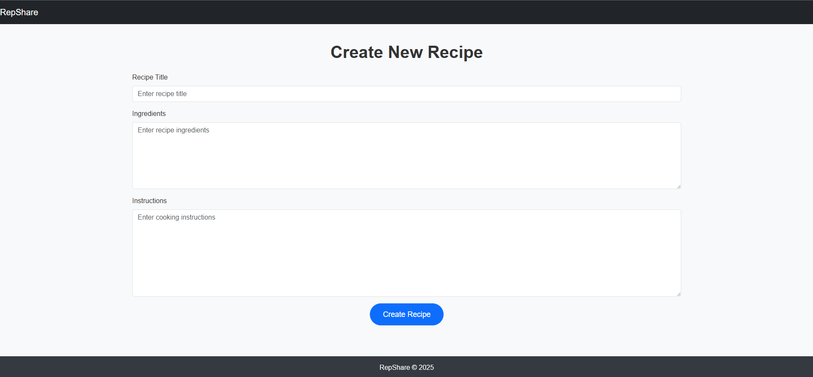
The create new recipe button redirects to a form submission page where users can add a recipe that includes the ingredients and instructions on how to prepare the recipe. More boxes could be added in future updates where users can add tags that can help sort through recipes.
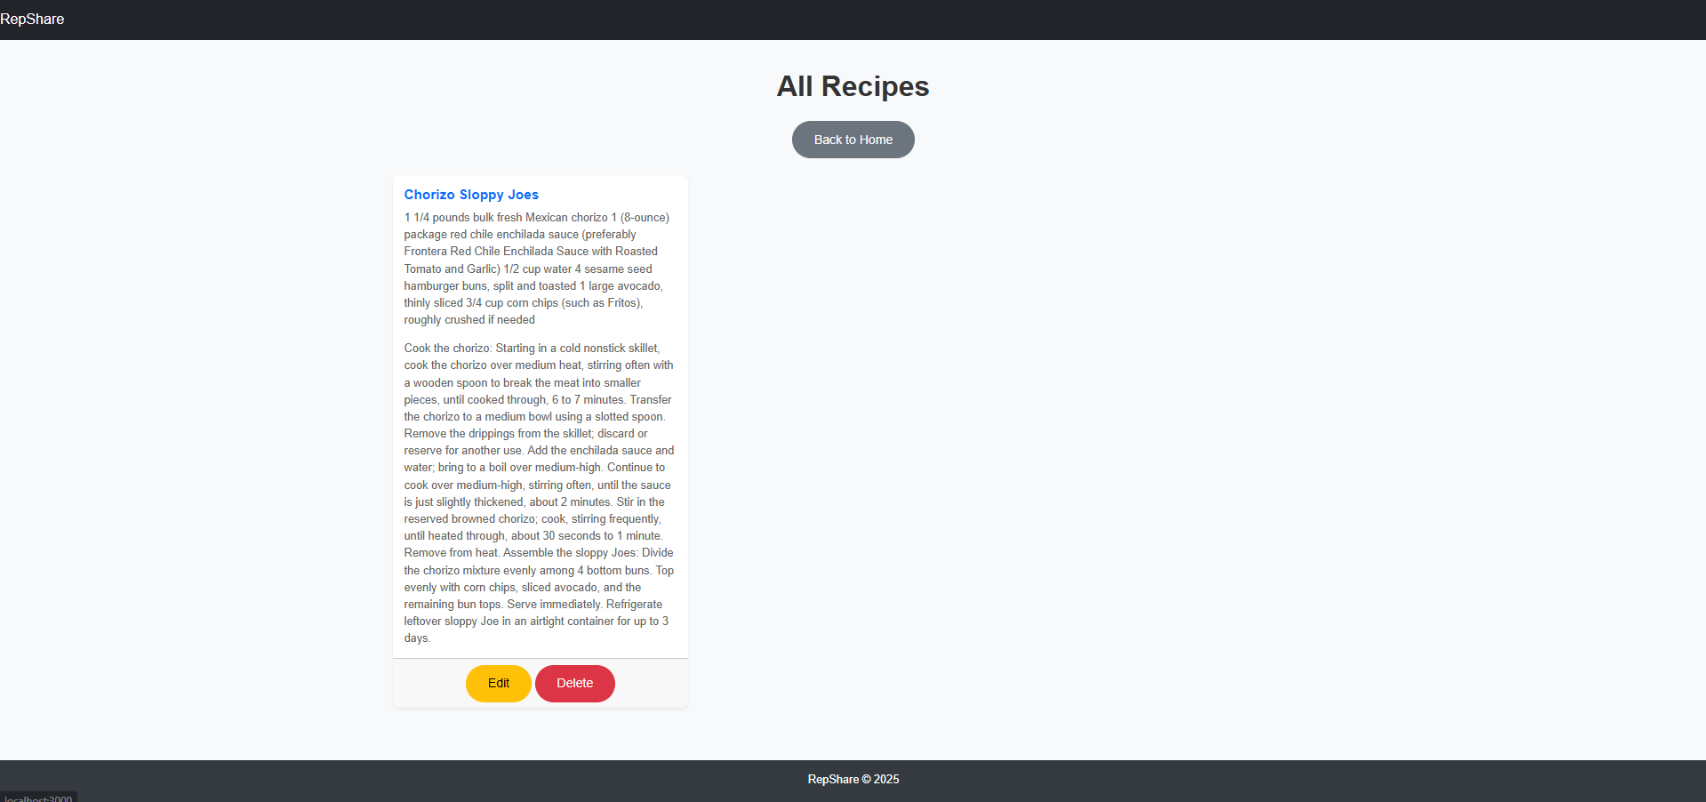
The all-recipes page displays all recipes that users have submitted. Currently the cards display all information about the recipe. This may be changed in the future so that the cards only display the titles of the recipe with a separate button that can redirect to the recipe page where all the information will be displayed so that the all-recipe page does not become flooded. A search function could also be added so that users can search using the tags that they previously added during the create recipe submission.

